Holly Oak Elementary School PTA Membership
By joining the PTA you have a VOICE!
- It is a great place to exchange ideas and improve your school. See a problem....work through the PTA to get it resolved.
Become a role model to your children
- By being a part of PTA you not only show your child that they are important to you but also their education.
Join The Holly Oak School PTA today as we continue to enrich the lives of our children.
Join now for only $10.00 per membership!
Name: _____________________________________________________
Address: ___________________________________________________
Contact Number: ____________________________________________
Member Name (First & Last) | Email Address | Contact Number

**Please note how much you are including for the PTA membership
Yes, I want to join the PTA! | $
Donations: any amount helps | $
TOTAL: | $
*Make checks payable to Holly Oak PTA

Child’s Name | Teacher | Room Number

I want to help with PTA activities
Name:
Preferred contact phone number/email:

Help your child’s class earn a popsicle party!
Classrooms with 100% participation will earn a popsicle party!

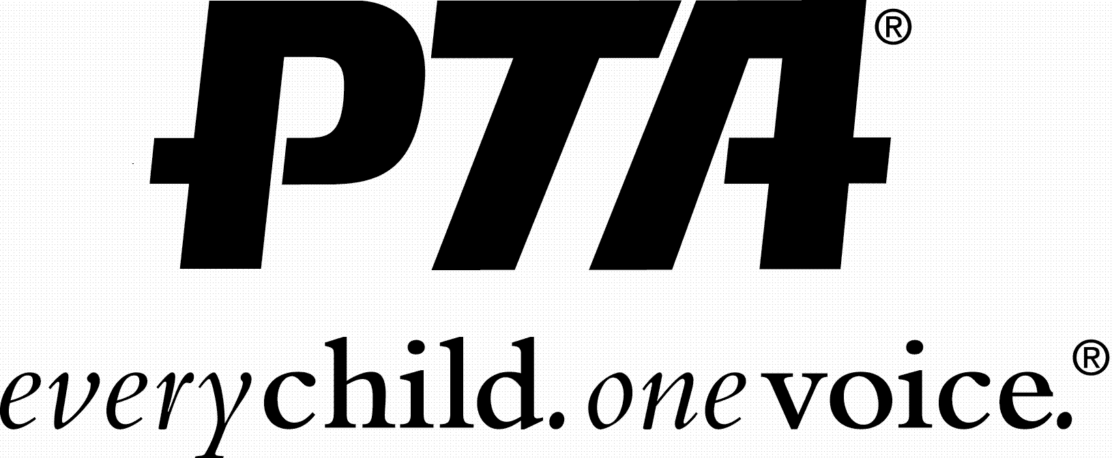
Return completed form and money/check to Holly Oak Office

